

**North South University**

**Department of Electrical & Computer Engineering**

**Assignment – 02 : System Modelling Diagrams**

**Group 4**

Prepared by:

*Zuhayer Islam (223 2061 642)*

*Tanvir Ahmed (223 1047 642)*

*Faheema Shaheed Tamanna (223 2144 642)*

*Shefa Tabassum (223 2993 042)*

This document is part of Assignment 2 for the course CSE327

Submitted to Dr. Mohammad Rezwanul Huq

Date: 13th August 2025

## Class Diagram

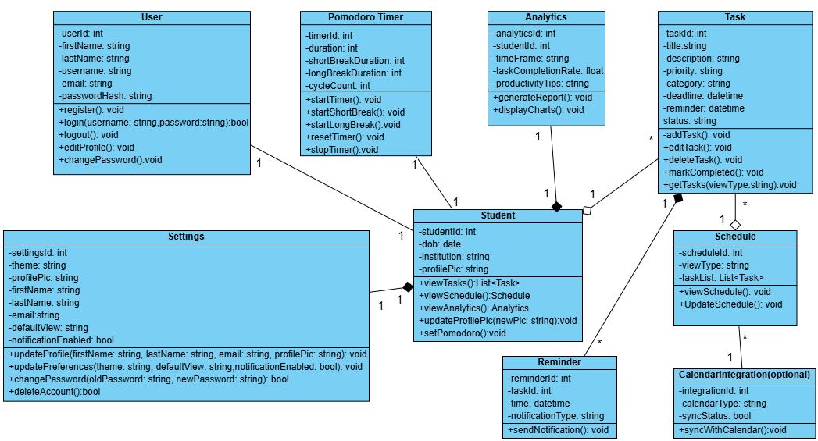

Completed By: *Shefa Tabassum (223 2993 042)*

## ER Diagram (Database Design)

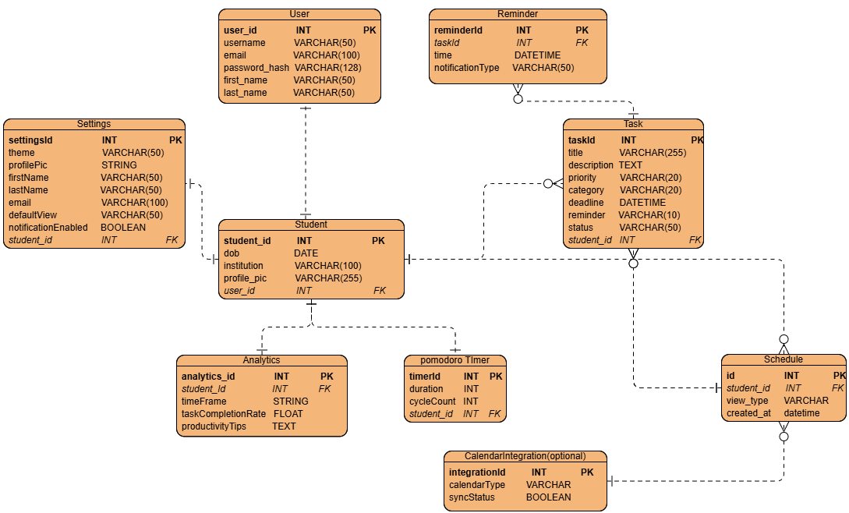

Completed By: *Shefa Tabassum (223 2993 042)*

## Sequence Diagram

**3.1. Registration flow**

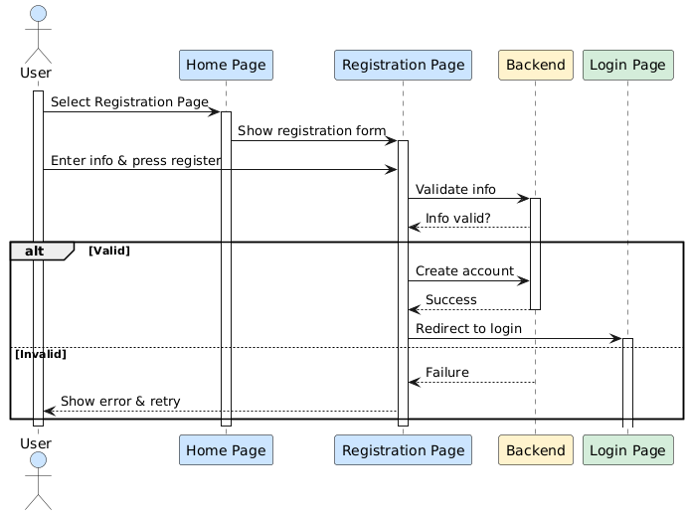

**3.2. Login flow**

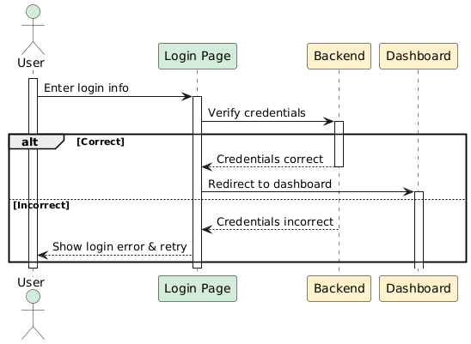

**3.3. Task management**

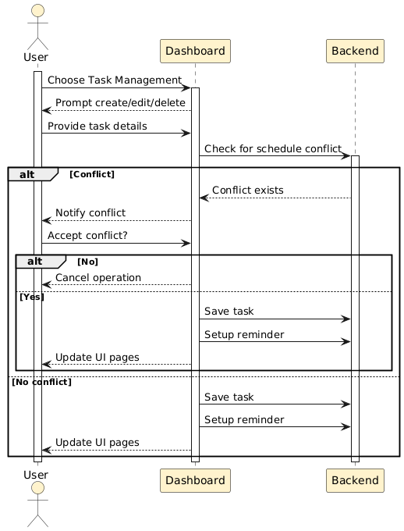

**3.4. Other Dashboard Actions**

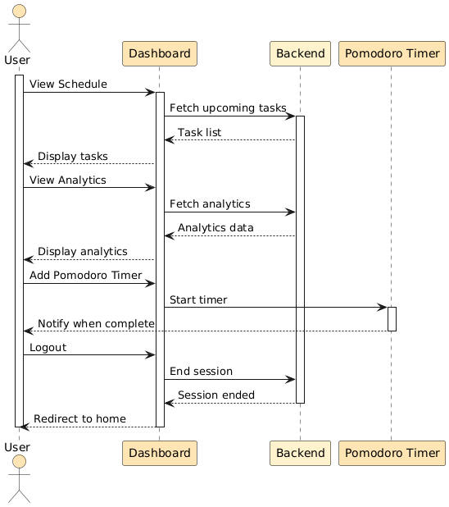

Completed By: *Faheema Shaheed Tamanna (223 2144 642)*

## Activity Diagrams

### **4.1 Activity Diagram for Registration/Login**

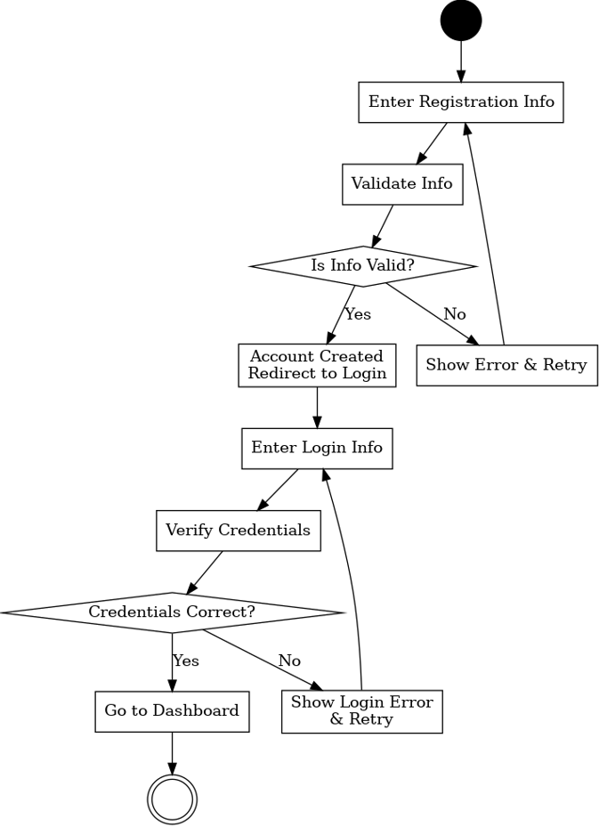

### **Add/Edit Task**

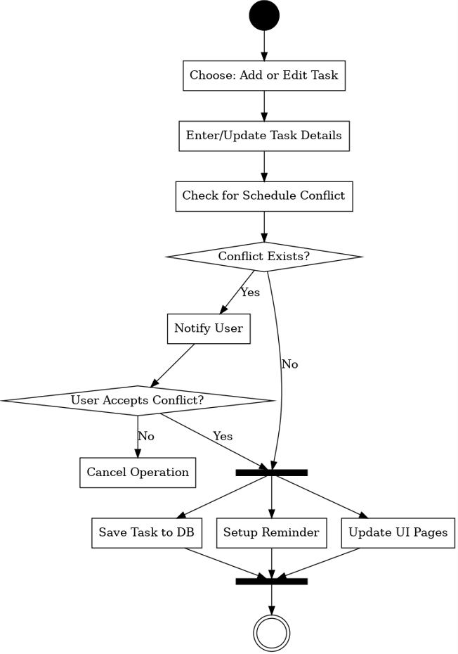

Completed By: *Tanvir Ahmed (223 1047 642)*

## State Machine Diagram

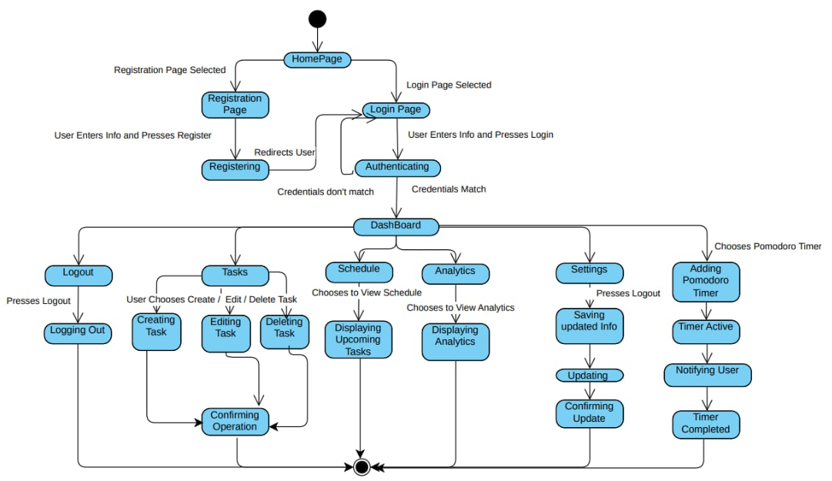

Completed By: *Zuhayer Islam (223 2061 642)*